How To install MongoDb?

=

* first, go to mongodb website and download mongodb latest version
* then click the downloaded file and install the complete version without custom version
* then after completing the mongodb , go to C:\Program Files\MongoDB\Server\6.0\bin and then copy the path

Then open environment variable –

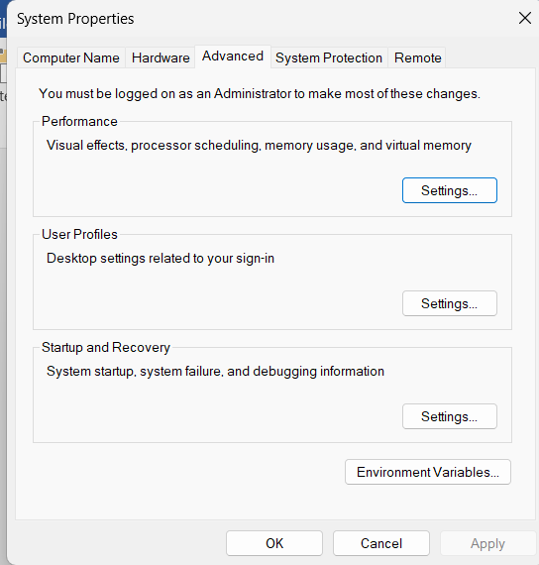

After opening environment variables

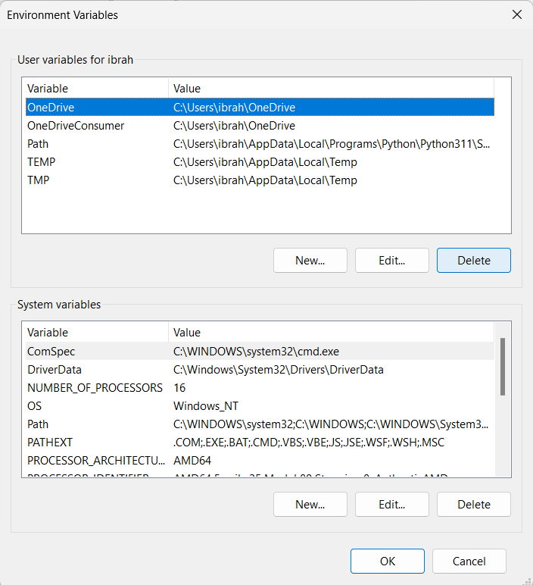

Select path and then click edit or direct click the path

Then click new and paste the path

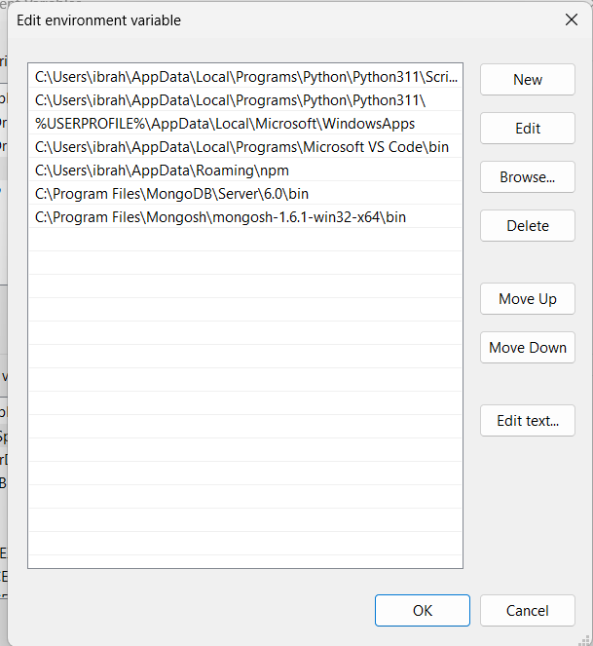

* After that go to mondoDB shell website and download mongoShell from this website -- <https://www.mongodb.com/try/download/shell>
* After that, unzip the file and copy or cut that folder and go to C drive and create a folder named **mongosh** and there paste that folder. After that go to **C:\Program Files\Mongosh\mongosh-1.6.1-win32-x64\bin** path and copy that path and paste it in environment variable like mongodb



* After that go to c drive and there create a folder name **data** and then create a folder name **DB** inside that **data** folder

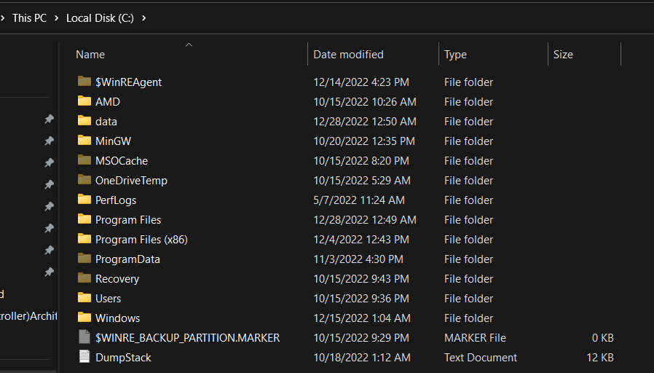

After clicking data folder we find DB folder

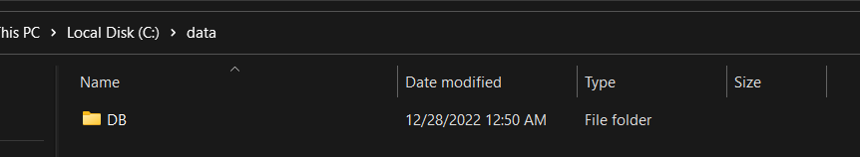

* Then after open cmd and type **mongod –version**  and we can fine which version is installed in our system

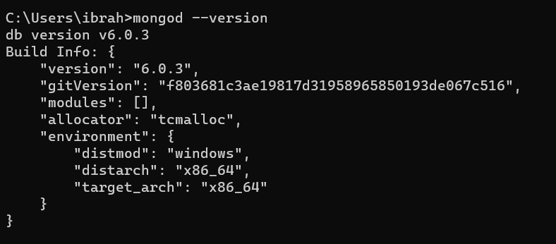

And again type **mongosh –version** to know which version of mongoshell is installed in our system

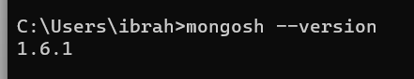

How to work with MongoDB ?

=

To work with mongodb first we need to start mongoDB then we can work with mongodb shell to create a database and update it and so on .

To do this,

* Open cmd and type **mongod** and start the server

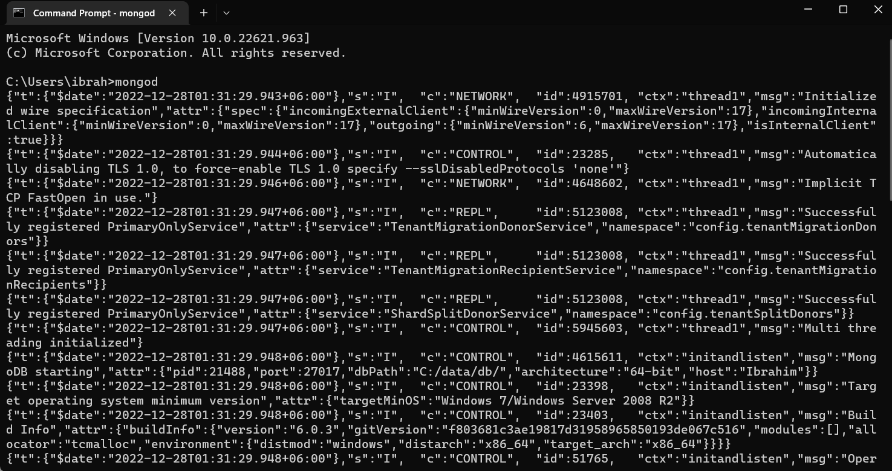

Then open another tab of cmd and there type **mongosh**

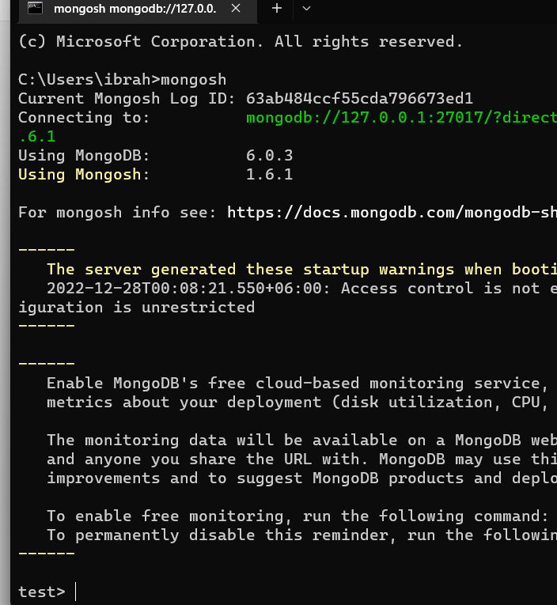

In this--- test> we can work with mongoDB shell

What is mongoBD?

=

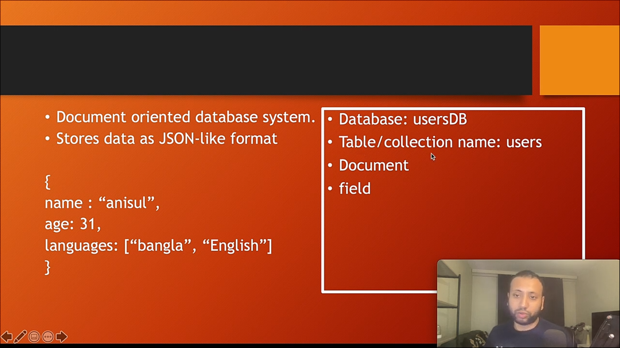

Here we can find :



RDBMS(Relational DataBase management System) Vs MongoDB terms :

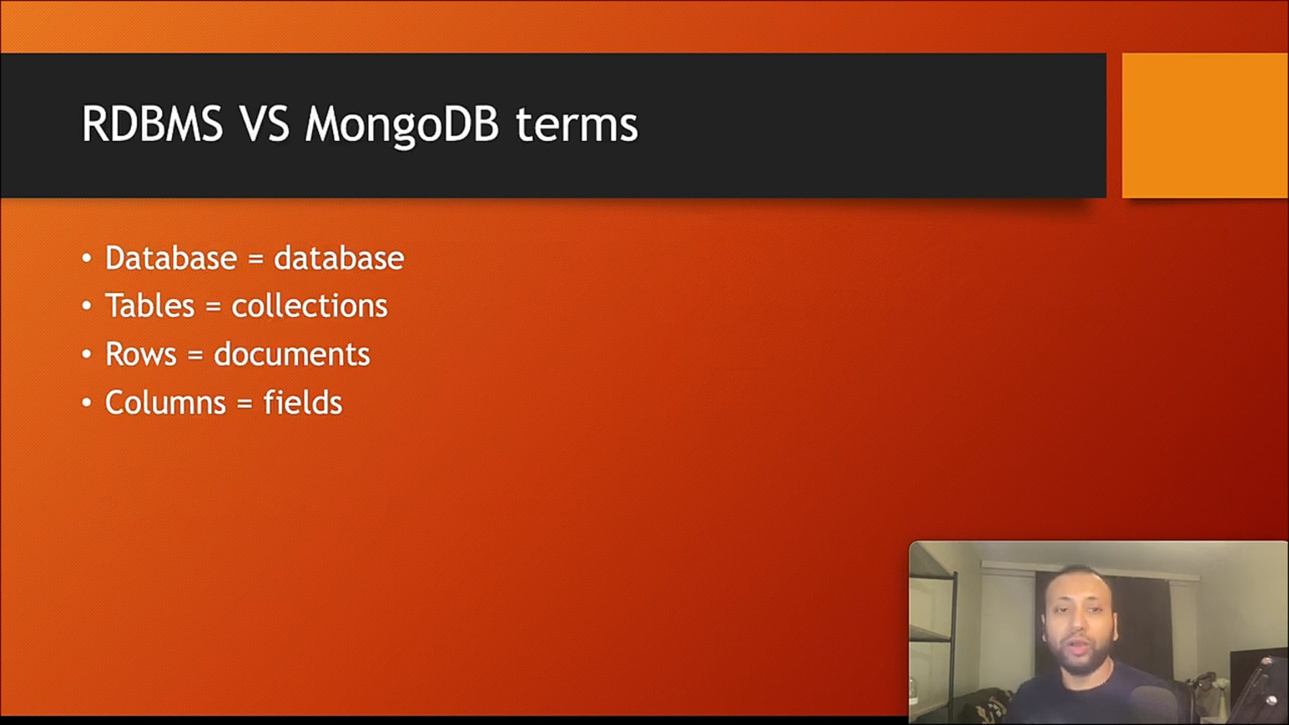

Command lines:

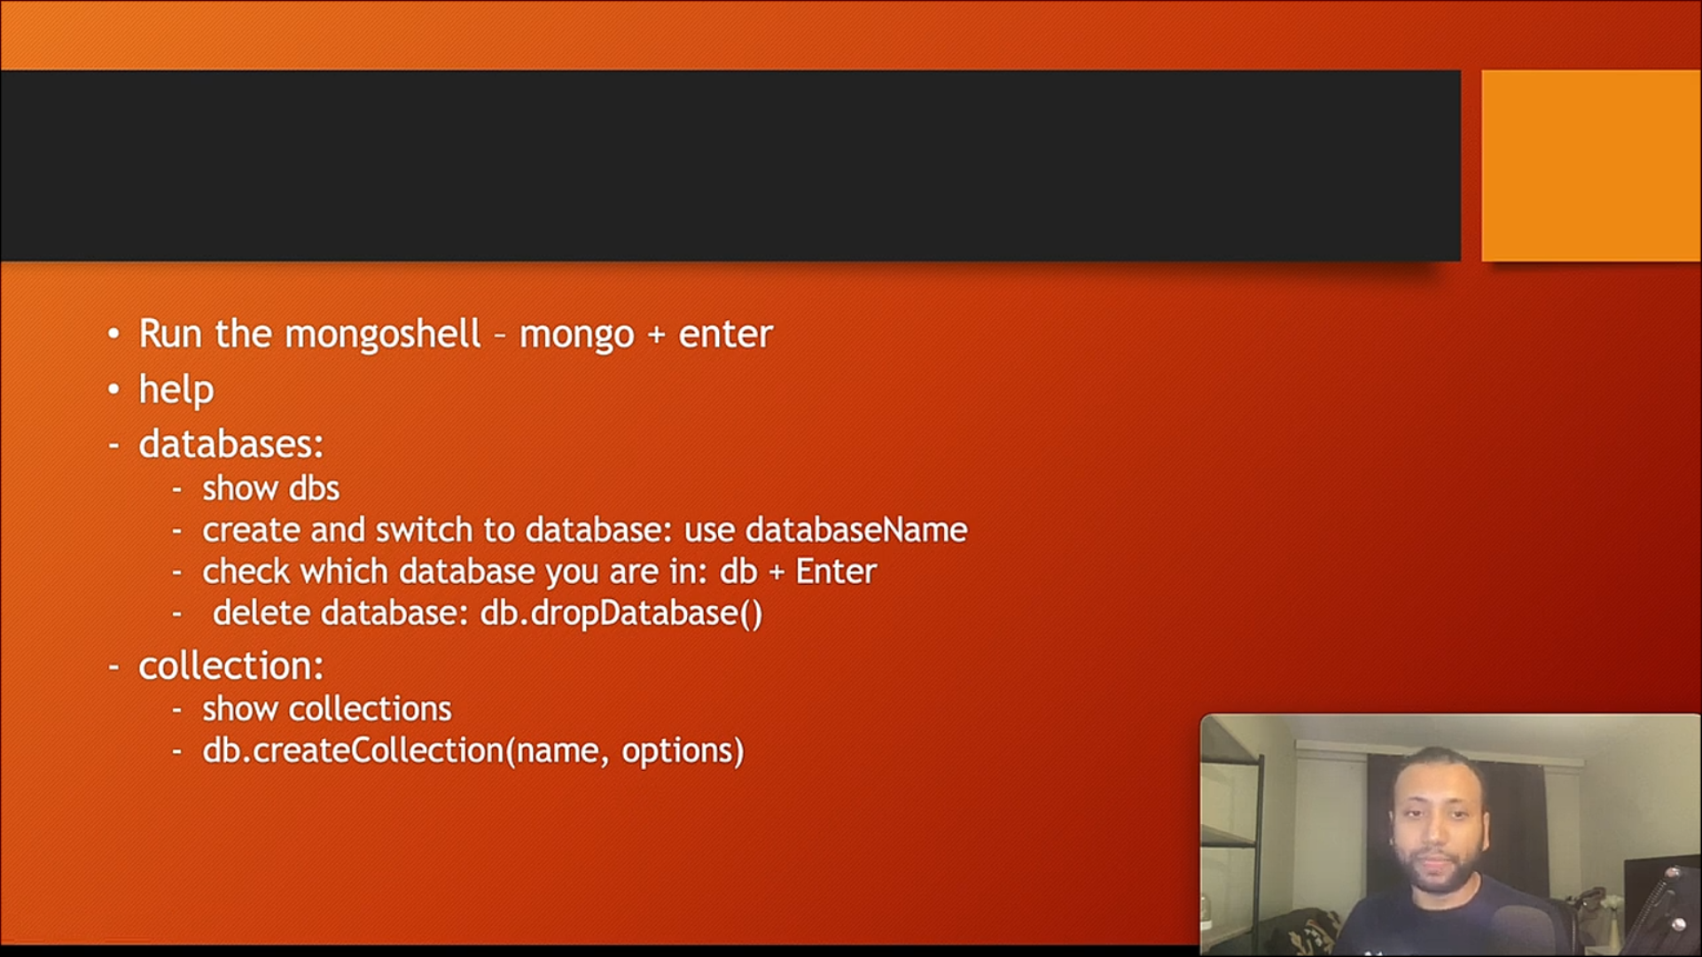

=

= in which database we are in

use database_Name = create database

|  |  |
| --- | --- |
| **Command** | **Working** |
| show dbs | showing all database |
| db | in which database we are using |
| use database_Name | create database |
| db.createCollection("name" ) | Create collections |
| show collections | Showing collections |
| db.dropDatabase() | Deleting database |
|  |  |